Interview at The Savoy Snooker Centre, Lewisham,, with world snooker champion John Pulman, Bruce Donkin and John James Carty (JJC):
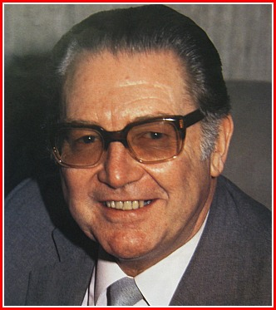
John Pulman and Bruce Donkin were close friends and associates of Joe Davis for many years. Pulman, the aspiring young professional, was one of the fiercest contenders for Joe’s title, but great player though he was, he never managed to beat Joe on level terms. In a match no quarter was given or asked, but away from the table there developed between Joe and John the greatest respect and affection.

John Pulman
Bruce Donkin, one of the most influential men behind the scenes in snooker, was Joe’s close friend for many years. Starting as a young referee at Leicester Square Hall, London, Bruce was to become an associate of the great man and Joe’s greatest successes were witnessed (and usually refereed by) Bruce.
When Joe collapsed at Sheffield in 1978, Bruce drove him straight to The London Clinic. Joe appeared to make a good recovery from the massive operations he underwent but he died in a Surrey nursing home on 10 July 1978.
Perhaps it is inevitable that these two old friends confirm the opinion that Joe Davis was the greatest, but let’s hear it in their own words:
JJC: How good was Joe Davis really?
John Pulman: He was the W.G. Grace of Snooker. He reached a position that no man has ever equaled in Snooker, probably never will. Look at this (waves a hand around the matchroom of the Savoy Centre, which is called “The Joe Davis Room”) – this is the sort of thing people do in memory of Joe Davis. He was the tops.
Bruce Donkin: He was the greatest player who ever lived. How else can I say it?
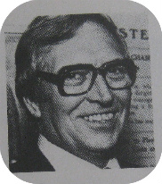
JJC: It has sometimes been suggested that Joe helped to maintain his position by avoiding opponents he didn’t want to meet?
John Pulman: Name one Bruce Donkin
Bruce Donkin: No player of any class or ability failed to meet Joe Davis – look at the records, he played them all.
John Pulman: There weren’t that many players around, but he didn’t dodge anybody – he had to play them all. No one was kept out of the professional game. I was welcomed as a professional at the age of twenty six.
Bruce Donkin: I always remember that the most common conversation in the dressing room during a Joe Davis match was the opponent saying to Joe (who’d be about ten frames in front) ‘For God’s sake, Joe, ease up and give me a chance. Let’s put on a bit of a show!’ Joe’s reply would be, ‘if you want to beat me do it by playing snooker.’ He was so hard; even if he was fifteen frames in front he’d want to make it sixteen.
JJC: So why was he so good?
John Pulman: Most people will say that the Australian, Walter Lindrum, was the best there ever was at billiards. Possibly he was, but between Walter and Joe at billiards there was nothing in it. In other words, Joe was a very fine billiards player. When it came to snooker, the cue ball control that he had achieved because of his wonderful knowledge of billiards put him streets ahead. He could drop the cue ball on a sixpence.
Bruce Donkin: And he really made that cue ball control work for him: when he was on a break he was rarely more than eighteen inches from the ball he was aiming at. Of course, as he always said, his purpose was to leave himself easy shots all the time.
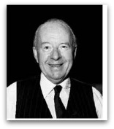
John Pulman: He was a great long potter too – if you left him half a chance he was in again.
Bruce Donkin: One thing that’s often overlooked – he persisted with practice always, even when he was the undisputed master.

Fred Davis

