COXA Golf Day 23rd June 2017
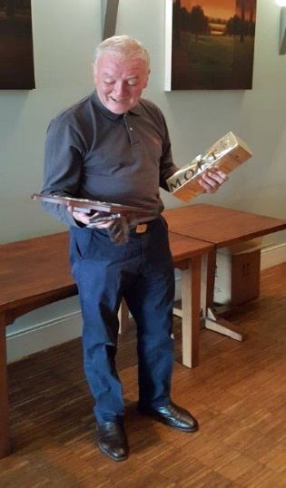

A stunned winner of the Stan Miller Memorial Trophy – David Leathem

In near perfect weather conditions the 2017 COXA Golf Day took place at Surrey Downs Golf course on 23rd June.
The main event of the day was the Stan Miller Memorial Trophy. The worthy and very popular winner was David Leathem with 38 stapleford points. David clearly delighted with his victory admitted that his previous criticism of the course may have been a little harsh. The frustration of a major road diversion on the way to the game was now also well forgotten.
It was good to have Brendan Williams playing in this event again and despite a late dash from Colchester, he took home the Eamon Taggart Memorial Trophy for the nearest the pin competition
Alongside the stapleford competition, a team competition was run for the first time. Twenty-seven golfers took part and were arranged into 9 teams of 3, with the highest score per hole of 2 players, counting as the team score. This proved to be a very popular format. Four teams returned very high scores in the 80’s. The ultimate winners, after count back, with 87 points was the team of Mick Powell, Ron Goodwin and Tommy McLaughlin.
For the third year in succession Tom Judge’s guest Phil Littlechild, won the Guests’ stapleford competition with an incredible 42 points.
A small profit was made on the day and a cheque for £150 was given to John McGuire’s daughter Claire and granddaughters Molly and Lilly in support of their charity run for Cancer Research.
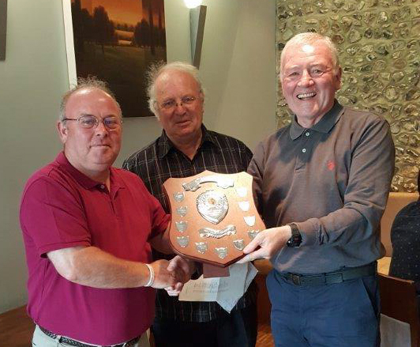
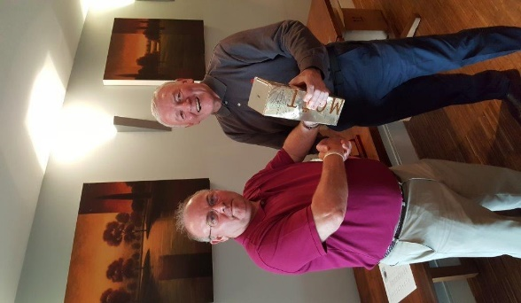
Left –Brendan presenting to David the Stan Miller Trophy

Right – David presenting to Brendan Champagne for winning the Eamon Taggart Memorial Trophy
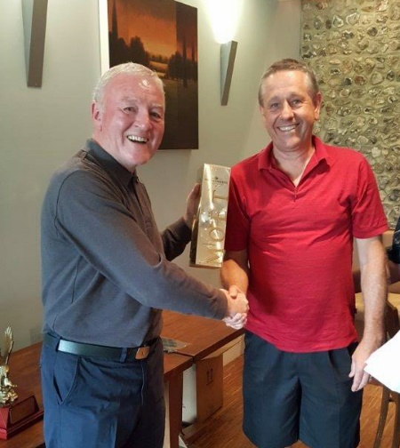
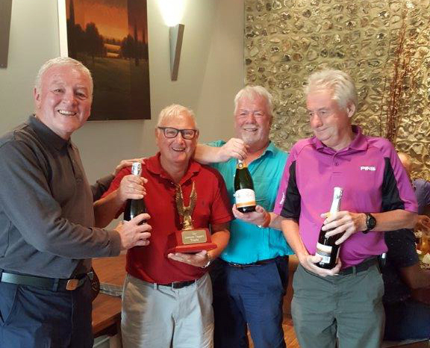
L – David presenting Team prize to: Mick Powell, Ron Goodwin, Tommy McLaughlin

R- David presenting Guest prize to Phil Littlechild

Final scores
42 points P Littlechild (G)
38 D.Leathem, G Rainger (G) T. McLaughlin (G)
37 R Goodwin (G)
36 T. Judge, M Powell, P Smith, J Kateley (G)
34 F. Hixson, J Flynn
33 L Mullane, J. McQueeney
32 D Hackshaw (G)
31 A. Coletta
30 B Williams
29 C Smith, C Bygraves (G)
28 M Duffy, M O’Sullivan , J Czezowski, P White
27 J McGuire
25 M Burke
24 S McGuire, P Davis
14 B Unthank (G)
Team Competition
87 pts: Team Powell & Team Duffy. 84: pts Team Coletta & Team Williams. 76 pts: Team Mullane
75: pts Team Hixson 71 pts: Team S McGuire. 70 pts: Team Leathem 65 pts: Team J McGuire
ATC 24/6/17

